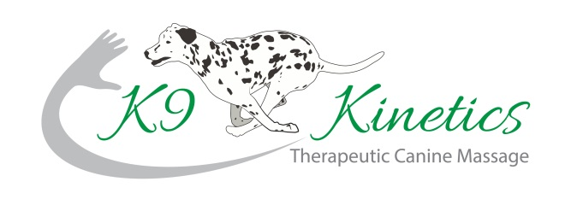Samantha Kable

Tel: 07876 530554

[sam@k9-kinetics.co.uk](mailto:sam@k9-kinetics.co.uk)

[www.k9-kinetics.co.uk](http://www.k9-kinetics.co.uk)

**VETERINARY CONSENT FORM**

|  |  |
| --- | --- |
| Owners Name: |  |
| Address: |  |
|  |  |
| Telephone No: |  |
| Mobile No: |  |
| Email: |  |

Dog’s Details

|  |  |  |  |  |  |
| --- | --- | --- | --- | --- | --- |
| Name: |  | Breed: |  | Colour: |  |
| Sex: |  | DOB: |  | Neutered: |  |

I Declare I am the legal owner of the above named dog and that all information presented is correct to the best of my knowledge. I give consent for my dog to be treated by Samantha Kable.

Owner Signature: …………………………………… Date: …………… ……………………

|  |  |
| --- | --- |
| Veterinary Surgeon: |  |
| Practice Stamp – Address & Telephone No: |  |

**YOUR VET MUST COMPLETE AND SIGN THE AREA BELOW**

|  |
| --- |
| Reason for approach, treatment, areas of concern: |
|  |
|  |
|  |
| Is the dog on any medication? YES/NO If yes, what? |

In your opinion is the dog named above in a suitable state of health to undergo Massage Therapy? Yes/No

**Signature of Veterinarian …….………………………………. Date ……………………**

Samantha Kable respects the Veterinary Surgeons Act 1966 and Exemption Order 1962 by never working upon an animal without gaining prior veterinary approval.